Weekly Report(Up until 13th November, 2015)
Anirudh Tiwari

Work Done
Up until last time, I was trying to classify single domain proteins from two domain proteins. Using the same idea, I tried to classify two domain proteins from three domain, three domain from four domain and so on.

Results
Single Domain vs Two Domain Proteins

Length vs Interaction Energy
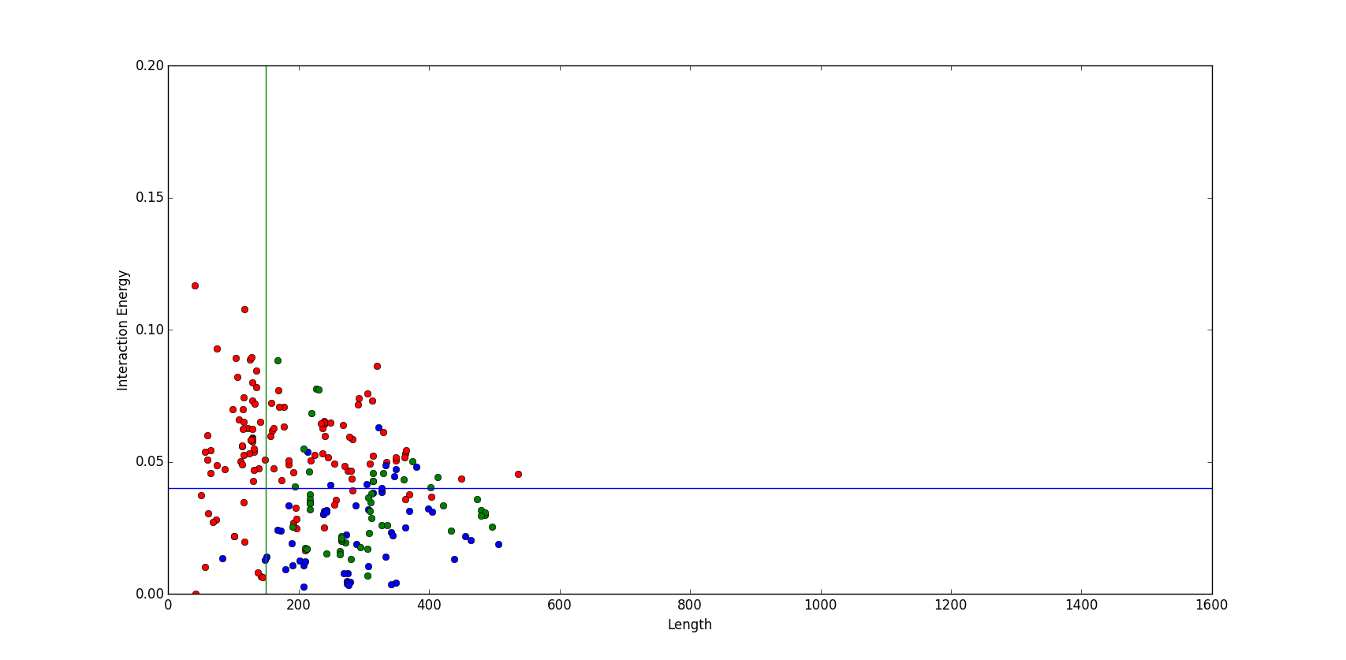
(red dots→ single domain, blue dots→two domain contiguous, green dots→ two domain non-contiguous)

Radius of Gyration vs Interaction Energy
(red dots→ single domain, blue dots→two domain contiguous, green dots→ two domain non-contiguous)
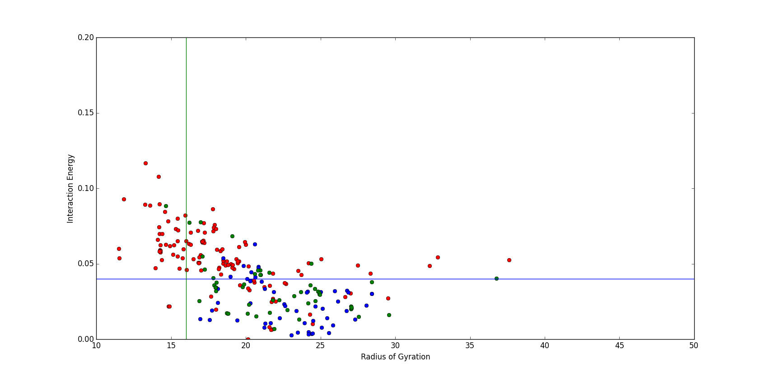
 | Length | Interaction Energy | Radius of Gyration | True Positives | False Positives
Single vs Two | >=150 | <=0.04 | >=16.0 | 82/108 | 12/120

Two Domain vs Three Domain Proteins

Length vs Interaction Energy
(red dots→ two domain, blue dots→three domain contiguous, green dots→ three domain non-contiguous)
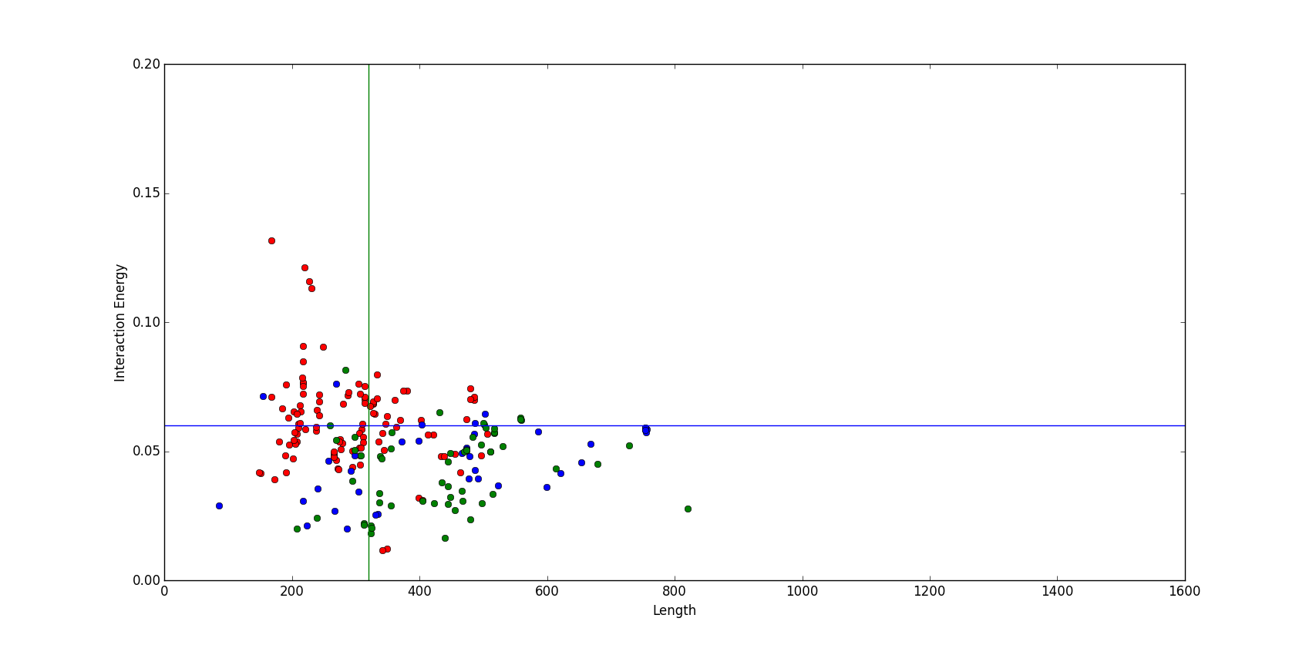

Radius of Gyration vs Interaction Energy
(red dots→ two domain, blue dots→three domain contiguous, green dots→ three domain non-contiguous)
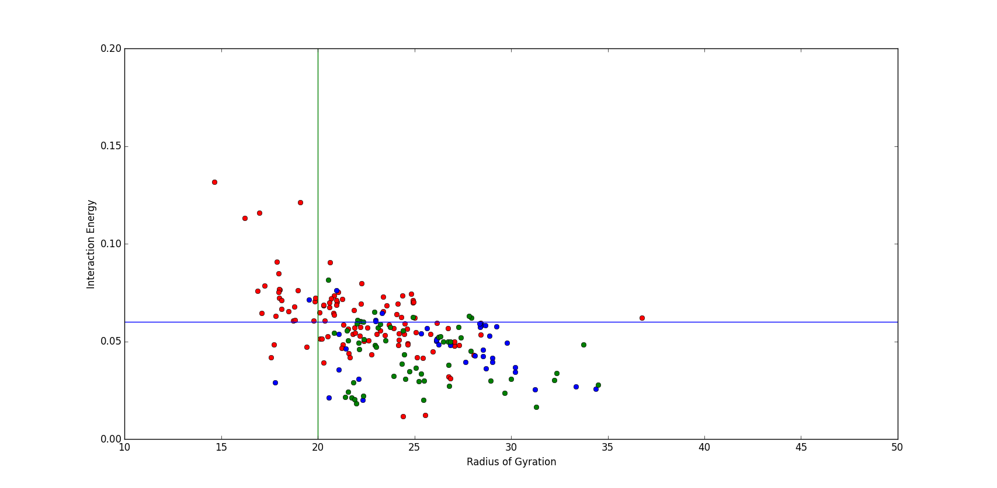

 | Length | Interaction Energy | Radius of Gyration | True Positives | False Positives
Two vs Three | >=320 | <=0.06 | >=20.0 | 65/97 | 16/112
Three Domain vs Four Domain Proteins

Length vs Interaction Energy
(red dots→ three domain, blue dots→four domain contiguous, green dots→ four domain non-contiguous)
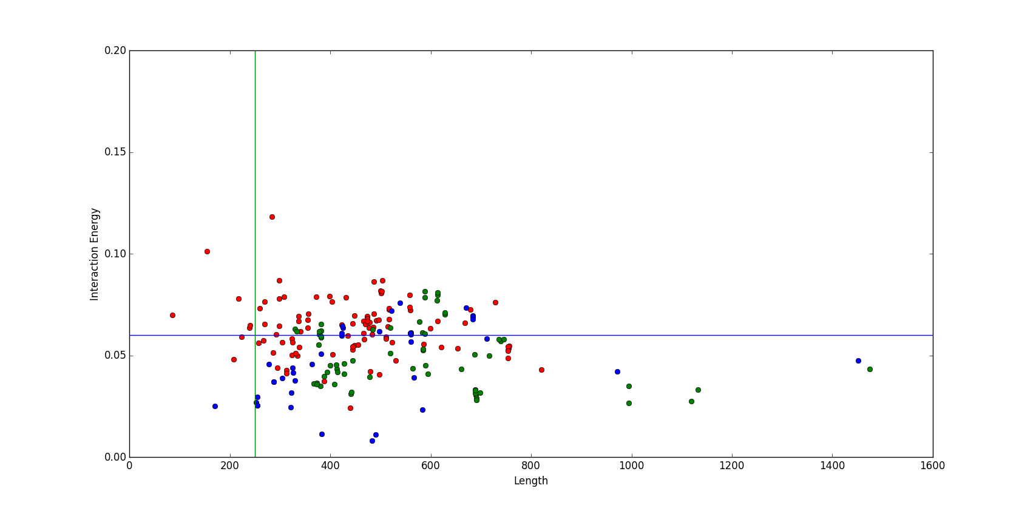
Radius of Gyration vs Interaction Energy
(red dots→ three domain, blue dots→four domain contiguous, green dots→ four domain non-contiguous)

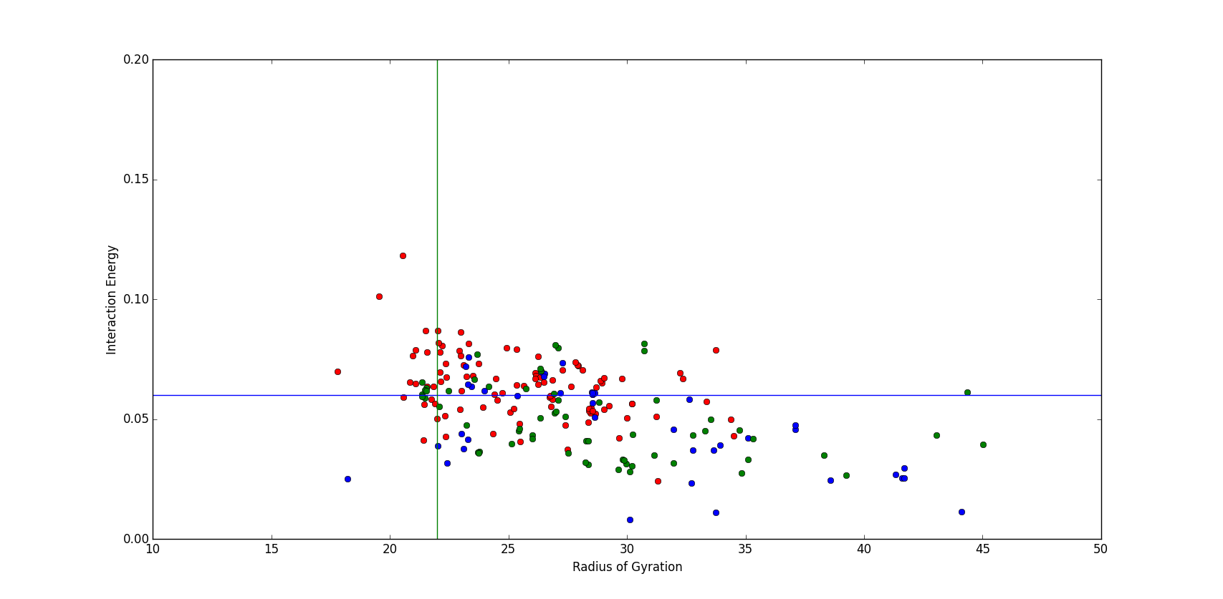

 | Length | Interaction Energy | Radius of Gyration | True Positives | False Positives
Three vs Four | >=250 | <=0.06 | >=22.0 | 67/102 | 33/98
Four Domain vs Five Domain Proteins

Length vs Interaction Energy
(red dots→ four domain, blue dots→five domain contiguous, green dots→ five domain non-contiguous)
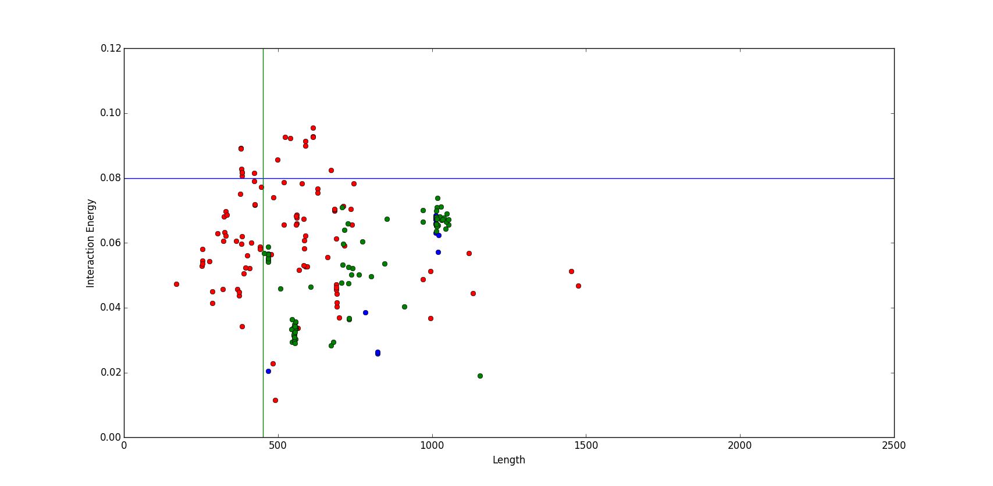

Radius Of Gyration vs Interaction Energy
(red dots→ four domain, blue dots→five domain contiguous, green dots→ five domain non-contiguous)
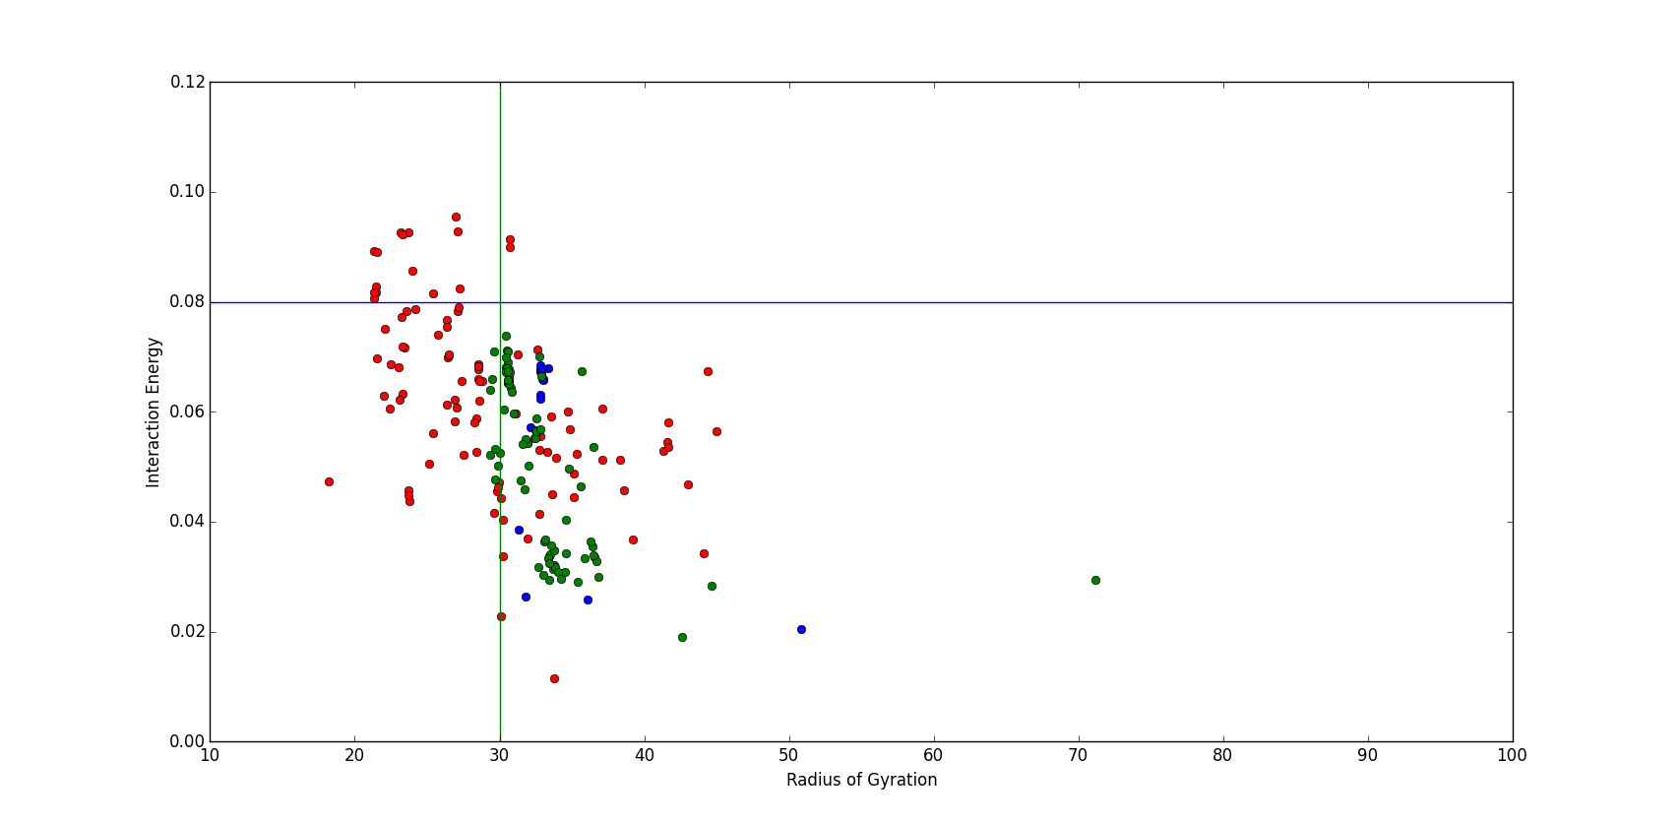

 | Length | Interaction Energy | Radius of Gyration | True Positives | False Positives
Four vs Five | >=450 | <=0.08 | >=30.0 | 93/100 | 22/98

Summary Of Results

 | Length | Interaction Energy | Radius of Gyration | True Positives | False Positives
Single vs Two | >=150 | <=0.04 | >=16.0 | 82/108 | 12/120
Two vs Three | >=320 | <=0.06 | >=20.0 | 65/97 | 16/112
Three vs Four | >=250 | <=0.06 | >=22.0 | 67/102 | 33/98
Four vs Five | >=450 | <=0.08 | >=30.0 | 93/100 | 22/98

Next Steps
- These results are based on CATH classification only, I'll try to incorporate SCOP information also to check whether it improves my result or not.
- This dataset of proteins is generated by me, I'll run it on Holland et al bench marked data set.

